“Київський фаховий коледж зв’язку”

Циклова комісія Комп’ютерної та програмної інженерії

**ЗВІТ ПО ВИКОНАННЮ**

**ЛАБОРАТОРНОЇ РОБОТИ №4**

з дисципліни: «Операційні системи»

**Тема: «Команди Linux для управління процесами»**

Виконали студенти

групи БІКС-03

Маламуж В.С.

Румянцев Г.А.

Хоменко А.П.

Перевірив викладач

Сушанова В.С.

Київ 2023

**Тема: “Команди Linux для управління процесами”**

**Мета роботи:**

1. Отримання практичних навиків роботи з командною оболонкою Bash.
2. Знайомство з базовими командами для управління процесами.

**Матеріальне забезпечення занять**

1. ЕОМ типу IBM PC.

2. ОС сімейства Windows (Windows 7).

3. Віртуальна машина – Virtual Box (Oracle).

4. Операційна система GNU/Linux – CentOS.

5. Сайт мережевої академії Cisco netacad.com та його онлайн курси по Linux

**Tasks for preliminary preparation.**

**Performed by student Malamuzh V.S.**

1. Прочитайте короткі теоретичні відомості до лабораторної роботи та зробіть невеличкий словник базових англійських термінів з питань призначення команд та їх параметрів.
2. На базі розглянутого матеріалу дайте відповіді на наступні питання:

2.1. Які команди для моніторингу стану процесів ви знаєте. Як переглянути їх можливі параметри?

2.2. Чи може команда ps у реальному часі відслідковувати стан процесів?

2.3. За якими параметрами можливе сортування процесів в команді top? Як переключатись між ними?

2.4. Які команди для завершення роботи процесів ви знаєте?

**Progress of work.**

**Performed by student Rumyantsev H.A.**

1. Початкова робота в CLI-режимі в Linux ОС сімейства Linux:
   1. Запустіть віртуальну машину VirtualBox, оберіть CentOS та запустіть її. Виконайте вхід в систему під користувачем: CentOS, пароль для входу: reverse ***(якщо виконуєте ЛР у 401 ауд.)*** та запустіть термінал.
   2. Запустіть віртуальну машину Ubuntu_PC ***(якщо виконуєте завдання ЛР через академію netacad)***
   3. Запустіть свою операційну систему сімейства Linux ***(якщо працюєте на власному ПК та її встановили)*** та запустіть термінал.
   4. Дайте відповіді на наступні питання:

* Як вивести вміст директорії /proc? Де вона знаходиться та для чого призначена? Охарактеризуйте інформацію про її вміст?
* Як вивести інформацію про поточні сеанси користувачів. Якою командою це можна зробити?
* Які дії можна зробити в терміналі за допомогою комбінацій Ctrl + C, Ctrl + D та Ctrl + Z?
* Чим відрізняється фоновий процес від звичайного. Де вони використовуються?
* Опишіть наступні команди та поясніть що вони виконують – команда jobs, bg, fg.
* Якою командою можна переглянути інформацію про запущені в системи фонові процеси та задачі?
* Як призупинити фоновий процес, як його потім відновити та при необхідності перезапусти?
  1. Запустіть термінал, та в командному рядку виконайте наступні дії для ознайомлення з роботою з процесами:
* запустіть команду top, проаналізуйте отриманий в цій команді результат та охарактеризуйте найбільш активні процеси у системі;
* призупинити виконання команди top (треба використати комбінацію клавіш);
* вивести інформацію про процеси за допомогою команди ps;
* наведіть 5 прикладів з використанням різних параметрів команди ps (наприклад, вивести тільки системні процеси, вивести процеси конкретного користувача, вивести дерево процесів тощо). Опишіть, що саме роблять обрані Вами параметри
* передивіться чи є у Вас запущені фонові процеси, які саме?
* відновити виконання призупиненого фонового процесу спочатку у позиції “на передньому плані” (foreground), потім ще раз його призупинити, а потім відновити його виконання у позиції “на задньому плані” (background)
* завершити роботу даного фонового процесу

1.

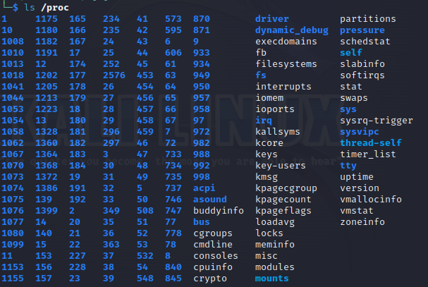

The contents of the /proc directory consist of files and subdirectories representing processes running on the system, as well as detailed system state information

Using the /proc directory, you can control and monitor the state of the system, as well as debug the processes running on it. Therefore, it is a useful tool for system administrators and software developers.

2.

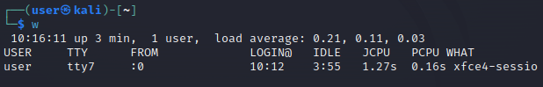

3. Ctrl + C, Ctrl + D and Ctrl + Z are very useful in the terminal. Here are some of the things you can do with these combos:

1. Ctrl + C - interrupts the execution of the current command and returns control to the user. This combination is especially useful when a command takes a very long time to execute or loops.

2. Ctrl + D - indicates that the input data is over. This combination is especially useful when entering input data into scripts or programs.

3. Ctrl + Z - suspends the execution of the current process and sends it to the background mode. This combination is useful when you need to suspend the execution of the current process to start another process and then return to the previous one.

4. Background process and normal process are two different modes of running processes in Linux.

A typical process is a process that runs in main mode, that is, it runs in the main terminal window and blocks its execution until the process is finished. The user can interact with this process, enter data into the terminal and receive the execution results.

A background process, on the other hand, does not block the execution of the terminal and works in the background. The user can continue to execute other commands and interact with the terminal while the background process is running. Background processes are typically used to run tasks that have a long running time or run in the background.

5. The jobs command allows you to view a list of all background processes running in the current terminal session. Each background process has its own job ID (job ID) and status (Running or Stopped).

The bg command allows you to resume the execution of a stopped background process that must be started in the background.

The fg command resumes execution of a stopped background process and brings it to the foreground so that the user can interact with the process.

6.

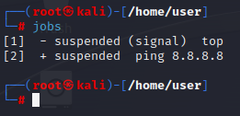.

7.

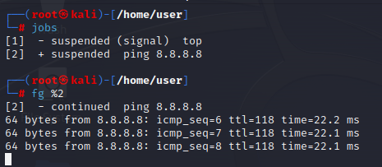

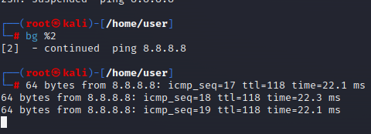

1.

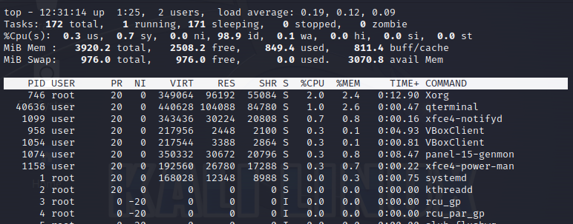

Xorg is an essential component of the Linux operating system and provides the basic functionality of the windowing system. It works as a background process and ensures the display of graphics on the screen, interacting with video card drivers and other devices.

QTerminal is a terminal emulator based on the Qt library and is part of the desktop environment. It is available for installation in most Linux distributions such as Ubuntu, Debian, Fedora, and others.

xfce-notifyd is a notification manager for the Xfce desktop. It is responsible for displaying notifications on the user's screen.

2.

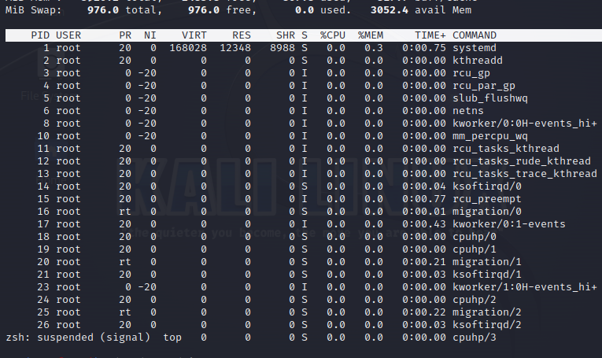

3.

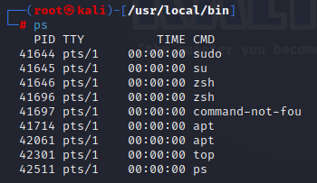

4.

-a means show processes of all users

- u - show detailed information about processes

- f indicates the output of processes in a tree structure, where each process is displayed in the context of its parent process.

--sort=-%mem - indicates that processes are sorted in descending order of memory usage.

--sort=-%cpu - indicates that the processes are sorted in descending order of CPU usage.

-aux - Here a means "show processes of all users", u - "show detailed information about processes" and x - "show processes not associated with the terminal"

5.

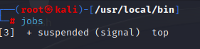

6.



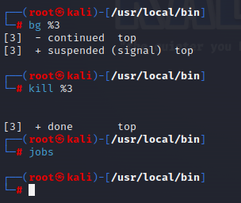

7.

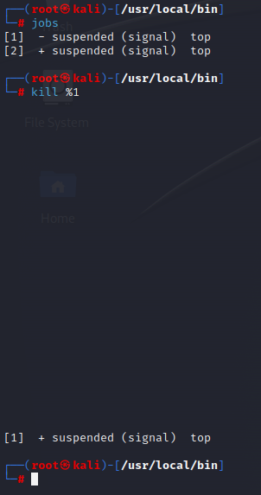

**Control questions**

**Performed by student Khomenko A.P.**

1. Яке призначення директорії */proc* в системах Linux. Яку інформацію вона зберігає?

The /proc File System

In the /proc system, the address space of another process can be accessed with file input and file output system calls, which allows a debugger to access a process being debugged with much greater efficiency. The page (or pages) of interest in the child process is mapped into the kernel address space. The requested data can then be copied directly from the kernel to the parent address space. In addition, /proc can be used to collect information about processes in the system.

The /proc file system is an OS mechanism whose interface appears as a directory in the conventional UNIX file system (in the root directory). You can change to /proc just as you change to any other directory.

1. Як серед будь-яких трьох процесів динамічно визначати, який з них в поточний момент часу використовує найбільший обсяг пам'яті? Який відсоток пам’яті він споживає від загального обсягу?

Using htop command:

“htop” is a useful substitute for “top” command – the standard process monitoring tool which comes pre-installed on all operating systems running Linux. htop is a real-time process monitoring software for Linux/Unix-like systems, Users can also interact with this utility. It might be thought of as the Linux equivalent of Task Manager in Windows. Htop is a more interactive program because it allows for value and tab flipping using the mouse and keyboard.

The CPU and memory use are displayed in the top-left panel of the screen. Sort the process by top CPU and memory usage: You can see the top running process by memory and CPU by sorting them. We can sort the processes using the htop command and any specific column by pressing the F6 key and then press enter

1. Як отримати ієрархію батьківських процесів в системах Linux? Наведіть її структуру та охарактеризуйте.

At every execution of a program, the kernel creates a process that loads execution details in memory. This created process is known as the parent process having single or multiple threads. Each process has assigned the unique PPID and PIDs automatically by the kernel.

While working with the Linux system, one should know about the PPIDs of the running processes. An issue with the child process may affect the other processes. In such cases, we may need to kill the parent process.

The PPIDs of running processes can be identified using multiple ways. The simplest approaches are through the “ps” command and “pstree” command.

How to Find PPID using pstree Command in Linux:

The “pstree” command is a good approach to identify the parent process ID (PPID) as it shows the parent-child relationship in a tree hierarchy.

Type the simply “pstree” command with the “-p” option in the terminal to check how it displays all running parent processes along with their child processes and respective PIDs

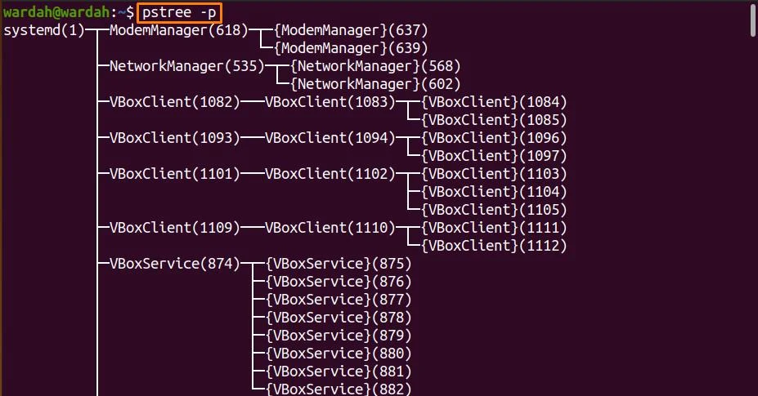

It shows the parent ID along with the child processes IDs.

Let’s check an example of “Mozilla Firefox” to get its PPID along with the complete process hierarchy. Execute the following command in the terminal

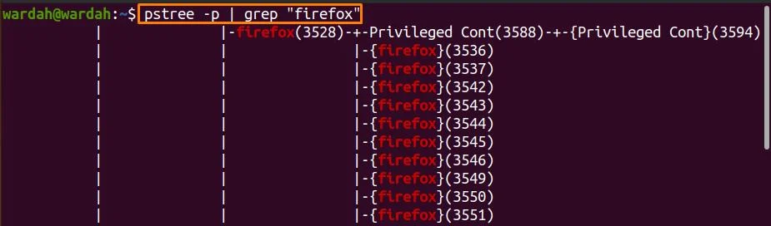

(grep is a command-line tool that helps to search for particular string)

In the mentioned results, we can see that 3528 is the PPID of the process “Firefox,” and all others are child processes.

To print only the parent process ID in the terminal, run the mentioned command



4.Чим відрізняється команда *top* від *ps*?

top is mostly used interactively (try reading man page or pressing "h" while top is running) and ps is designed for non-interactive use (scripts, extracting some information with shell pipelines etc.)

top allows you display of process statistics continuously until stopped vs. ps which gives you a single snapshot.

ps - (Process Status) - It reports a snapshot of current processes.

top (Table Of Processes) - is a task manager program displays information about CPU and memory utilization.

top enables you to see your processes ordered by the amount of processor power they use. ps enables you to see all your processes, or just the processes used by certain users, for example root or yourself.

top should be used to see which processes are most active, ps could be used to see which processes you (or any other user) are running currently.

for more information about how to use top and ps, run man top or man ps in your terminal

For CPU usage, ps displays average CPU usage over the lifetime of the process as it is instantaneous and would always be 0% or 100%. top gives a more instantaneous look at it from averaging over recent polls.

5.Які додаткові можливості реалізує *htop* в порівнянні з *top*?

top command is used to show the background Linux processes. A dynamic real-time view of the running system can be viewed by using this utility. More accurately, summarized information of the system and the list of processes or threads based on CPU usage, which is currently managed by the Linux Kernel can be viewed as the output of the command.

Often this utility is being used by System Administrators, that provide a limited interactive interface for process manipulation as well as a much more extensive interface for personal configuration encompassing every aspect of its operation. By default, 3 secs, the list will be updated.

htop is a new and improved form of top command, and it includes many improvements. htop supports mouse interaction on process list, uses colour in its output and gives visual indications about processor, memory and swap usage. It encapsulates all the functionality of top, and it comes with some advanced functionalities as well.

The interactive terminal just advanced and searching, filtering and sorting options are already available in the terminal. The command option will show the entire path.

Since the output is colored and scrolled using the mouse vertically and horizontally, the operations can easily be performed. Also, you no longer needed to enter the process number or priority value to re-nice a process. By pressing e, it will show the environment of the process. If you check out the bottom of the htop interactive page, you will find the menu for actions on a process.

Therefore System Administrators may be more inclined to use htop over top due to its rich display option and ease of use.

6.Опишіть компоненти вашої мобільної ОС для здійснення моніторингу запущених в системі процесів?

iOS provides several components for monitoring processes running in the system. These components are designed to help you diagnose performance issues, troubleshoot problems, and optimize resource usage. Here are some of the key components:

Activity Monitor: The Activity Monitor is a graphical user interface (GUI) tool that displays information about processes running on your iOS device. It shows you the CPU, memory, energy, and network usage of each process, as well as other information like process ID, user, and status. You can use the Activity Monitor to identify processes that are using too much resources, causing problems, or not responding.

Instruments: Instruments is a powerful profiling and performance analysis tool that is included with Xcode, Apple's integrated development environment (IDE). It allows you to monitor and analyze the performance of your iOS apps and system processes in real-time. Instruments provides a wide range of tools for monitoring different aspects of your system, such as CPU, memory, I/O, and network usage.

Terminal Commands: As mentioned earlier, you can also use command-line tools and utilities in the Terminal app to monitor processes running on your iOS device. The ps command can be used to display information about running processes, while top provides real-time information about resource usage. You can also use the kill command to terminate processes that are causing problems.

System Logs: iOS logs system events and messages to various files, which can be accessed using the Console app on your Mac or third-party apps on your iOS device. These logs contain information about system processes, errors, warnings, and other events that can help you diagnose problems and monitor system activity.

By using these components together, you can get a comprehensive view of the processes running on your iOS device and identify any issues that may be affecting performance or stability.

7.Чи підтримує Ваша мобільна ОС термінальне керування роботою процесів, опишіть як саме.

iOS supports terminal control of processes through the use of command-line tools and utilities available in the Terminal app.

Here are some common commands you can use to control processes in the terminal on iOS:

ps: This command displays a list of currently running processes on your iOS device. You can use it to find the process ID (PID) of the process you want to control.

kill: This command sends a signal to a process to terminate it. You can use it to stop a process that's not responding or behaving as expected. The syntax for the kill command is kill <PID>.

top: This command provides real-time information about running processes, such as their CPU and memory usage. You can use it to monitor the performance of your iOS device.

bg and fg: These commands allow you to move a process to the background (i.e., stop it from running in the foreground) or bring it back to the foreground. To move a process to the background, you can use ctrl + z, which will suspend the process, and then use the bg command to resume it in the background. To bring a process back to the foreground, you can use the fg command.

nohup: This command allows you to run a process in the background even if you log out of your terminal session. To use nohup, you can prefix your command with nohup, like this: nohup <command> &.

It's important to note that some of these commands require root access, which means you may need to jailbreak your iOS device to use them. Additionally, improperly terminating a process can cause system instability or data loss, so be sure to use these commands carefully and only when necessary.

8.Чи можливо поставити сторонні програмні засоби, що дозволяють організувати управління та моніторинг роботою процесів у Вашому мобільному телефоні. Коротко опишіть їх.

Yes, it is possible to supply third-party software tools that allow you to organize the management and monitoring of processes in iOS. Here are some examples of third-party software tools that can be used for this purpose:

iStat Menus: iStat Menus is a system monitoring tool that allows you to track the performance of your iOS device in real-time. It provides detailed information about CPU, memory, disk usage, network activity, and other system parameters. You can use iStat Menus to monitor processes, set alerts for system events, and customize the display of system information.

App Tamer: App Tamer is a process management tool that allows you to control the CPU usage of your iOS apps. It automatically slows down or pauses apps that are using too much CPU, freeing up resources for other tasks. App Tamer can also prevent background apps from consuming too much CPU, which can extend the battery life of your iOS device.

Process Monitor: Process Monitor is a process monitoring tool that allows you to view detailed information about running processes on your iOS device. It displays the process name, process ID, CPU usage, memory usage, and other parameters. Process Monitor also provides a graphical representation of CPU and memory usage, making it easy to identify processes that are consuming too much resources.

System Status Lite: System Status Lite is a system monitoring tool that provides information about CPU usage, memory usage, disk usage, and network activity. It also allows you to monitor battery usage, device temperature, and other system parameters. System Status Lite can be used to monitor processes, set alerts for system events, and customize the display of system information.

These third-party software tools can be used to supplement the built-in process monitoring and management tools in iOS. They provide additional features and functionality that can help you optimize the performance and stability of your iOS device.